8. INFORMATION ON THE NATIONAL HIGHER EDUCATION SYSTEM

Higher education in Norway: Legislature

The Ministry of Education and Research has the overall responsibility for higher education in Norway. Higher education is offered by four types of higher education institutions: university (universitet), specialized university institution (vitenskapelig høyskole), accredited university college (akkreditert høyskole), and university college with accredited study programmes (høyskole med akkrediterte studier). The differences between the types of higher education institutions are related to their self-accrediting authority.

All public and private higher education in Norway is subject to the Act Relating to Universities and University Colleges (Lov 2005-04-01 nr 15). An institution’s right to award specific degrees and the prescribed lengths of study are codified in Regulation concerning degrees and titles (FOR 2005-12-16 nr 1574). The awarding of master’s degrees is regulated by the Regulations on requirements for awarding a master’s degree (FOR 2005-12-01 nr 1392).

Since 2002 Norway has adhered to the objectives of the Bologna Process in the European Higher Education Area. Most of the elements have been implemented through the reform of the Norwegian higher education system carried out in 2003. Central to the reform has been a transition from the former degree system to the bachelor's, master’s and doctoral degree structure, with a few exceptions.

Norwegian higher education qualifications make up the levels from 6 to 8 of the Norwegian Qualifications Framework for Lifelong Learning (NQF) from 2011, which is the national overarching qualifications framework1. It describes the levels of qualifications as defined by the total learning outcomes in terms of the knowledge, skills and general competence that graduates at various levels should have achieved2.

NQF was referenced to the European Qualifications Framework (EQF) in 2014.

Quality assurance and accreditation of institutions and programmes
The Norwegian Agency for Quality Assurance in Education (NOKUT) is an autonomous governmental agency which provides external supervision and control of the quality of Norwegian higher education, as well as of all tertiary vocational education3. NOKUT accredits new study programmes, controls the existing ones, and provides
a cyclic evaluation of the institutions’ quality assurance systems for educational provision.
An accredited higher education institution is granted the right to offer educational provision, without having to apply to NOKUT for specific programme accreditation,
in accordance with the authority that its institutional category implies:
- Universities may without external accreditation establish study programmes at all levels.
- Accredited university colleges have to apply for the accreditation of programmes at master and doctoral levels.
- In those fields where specialized university institutions and accredited university colleges have the right to award doctorates or corresponding degrees, they may themselves decide which study programmes and disciplines the institution shall provide.

University colleges without institutional accreditation must apply to NOKUT for accreditation of study programmes at all levels.

Lists of all accredited institutions, as well as of all accredited study programmes at the university colleges without institutional accreditation are available on www.nokut.no

Admission requirements
The Higher Education Entrance Qualification is the successful completion of Norwegian upper secondary education with some specified courses. The Certificate
of Upper Secondary Education and Training (Vitnemål for videregående opplæring) is based on 13 years
of schooling.

Admission may also be gained by means of other qualifications recognized as being on a par with the Higher Education Entrance Qualification, such as recognition of prior learning and work experience.

Some fields of study have additional entrance requirements.

Academic credit system
All Norwegian higher education institutions use a system of credits (studiepoeng) for measuring study activities considered equivalent to the European Credit Transfer and Accumulation System (ECTS). 60 ECTS credits (studiepoeng) are allocated to the workload of a full year of academic study, equivalent to 1500-1800 hours of study. 30 ECTS credits are normally allocated to one semester’s full-time study. The academic year normally lasts for 10 months and runs from August to June.

¹ National generic learning outcomes descriptions’ levels for the bachelor’s, master’s and doctoral degrees were defined by the Instructions on the Norwegian Qualifications Framework for Higher Education in 2009.

² Learning outcomes for a specific NQF level show the minimum of what each learner should know, understand and be able to do after completing a learning process.

³ Tertiary vocational education (TVE), level 5 in the NQF (EQF), is provided by fagskoler, which are considered as tertiary vocational education institutions. TVE is based on upper secondary education and training or equivalent competence. Courses have duration of from six months to two years. All provisions must be accredited by NOKUT.

Degrees and qualifications

NQF (EQF) Level 6: Bachelor (1st cycle)
Bachelor's degree is awarded after three years of full-time study (180 ECTS). Some bachelor’s degrees, in the field of music and performing arts, consist of four-year bachelor’s programmes (240 ECTS).
Teacher education for primary and lower secondary school, years 1-7 and years 5-10 has been a four-year professional programme (240 ECTS) prior to its reform on 1 January 2017, when it became a five-year integrated master’s degree.
University college graduate (høyskolekandidat) is a two- year degree (120 ECTS), a short cycle degree within the first cycle. Holders of this degree may in some cases continue their studies in a bachelor programme and thus obtain a bachelor’s degree.

NQF (EQF) Level 7: Master (2nd cycle)
Master's degree is normally obtained after two years of study (120 ECTS), following the completion of a bachelor’s degree. A master’s degree programme includes independent work (normally a thesis) of between 30 and 60 ECTS.
Experience-based master’s degree has a scope of 90 or 120 ECTS (including independent work of at least 20 ECTS).
Integrated master’s degree is a five-year study programme (300 ECTS) which results in a master's degree, with no intermediate bachelor's degree. An exception is

the Master of Architecture programme at the Oslo School of Architecture and Design, which has a scope
of 330 ECTS.
In the fields of medicine, psychology and theology, professionally oriented degrees/qualifications of six years’ duration (360 ECTS) are awarded; in the field of veterinary science - after 5 ½-6 years. They have retained the title/degree candidata/candidatus from the former degree system.

NQF (EQF) Level 8: Doctoral degree (3rd cycle) Philosophiae doctor (ph.d.) is awarded after three years of study, following the completion of a master's degree or a five to six-year professionally oriented degree/qualification.
Philosophiae doctor in artistic research
(ph.d. i kunstnerisk utviklingsarbeid) is awarded after three years of study in the field of creative and performing arts. In 2018, the degree replaced former Diploma, artistic development programme, which will be phased out by 2025.
Doctor philosophiae (dr. philos.) is conferred on graduates who have qualified for a doctoral degree on their own, without formal research training.

Descriptions of the educational qualifications are given in the Norwegian Qualifications Framework for Lifelong Learning at www.nokut.no/nkr

The Norwegian Education System
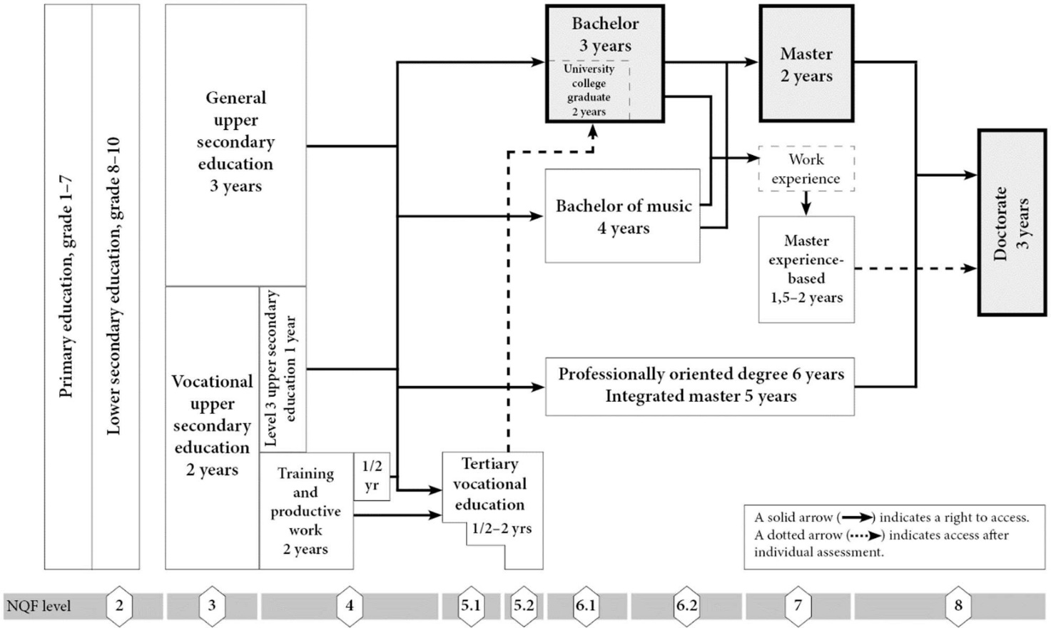

NOKUT, April 2021

